**Español 1-**

Please read **all** the instructions. Please turn in when **all** centers are completed.

**Centro #3- Read 1-2 Books**

Book 1:

What do the pictures tell you about the book?

What’s this book about?

What are 3 words I recognize?

What are 3 words I looked up?

Book 2:

What do the pictures tell you about the book?

What’s this book about?

What are 3 words I recognize?

What are 3 words I looked up?

**Centro #4- Dibujar (to draw)**

1. Use a white piece of paper.
2. Choose from 1,2,3,4:
   1. guapo/feo
   2. grande/pequeño
   3. alto/bajo
   4. inteligente/estúpido
3. Draw and label your picture
4. Put your name on your picture
5. Leave it in the basket on the desk

**Centro #6- Vocabulario**

**A. Please match the word to the correct letter:**

**1. guapo ______**

A. 

B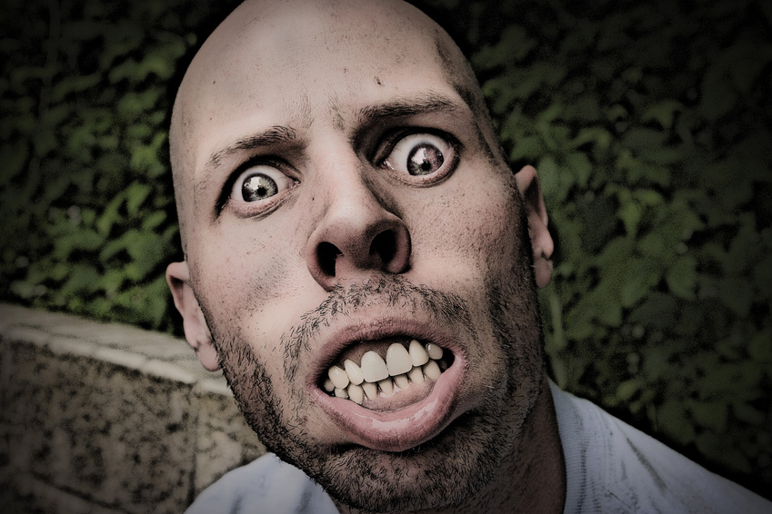

C. 

D.

E. 

F. 

G.

**2. feo _______**

**3. grande _______**

**4. pequeño _______**

**5. alto _______**

**6. bajo _______**

**7. inteligente**

**_______**

**B. Please use the vocabulary words in a sentence:**

**Ejemplo: Él es guapo.**

**Juan es inteligente.**

1. **_____________________________________________**
2. **_____________________________________________**
3. **_____________________________________________**
4. **_____________________________________________**
5. **_____________________________________________**
6. **_____________________________________________**
7. **_____________________________________________**